Public Service Authority Evaluation and Recommendation Committee
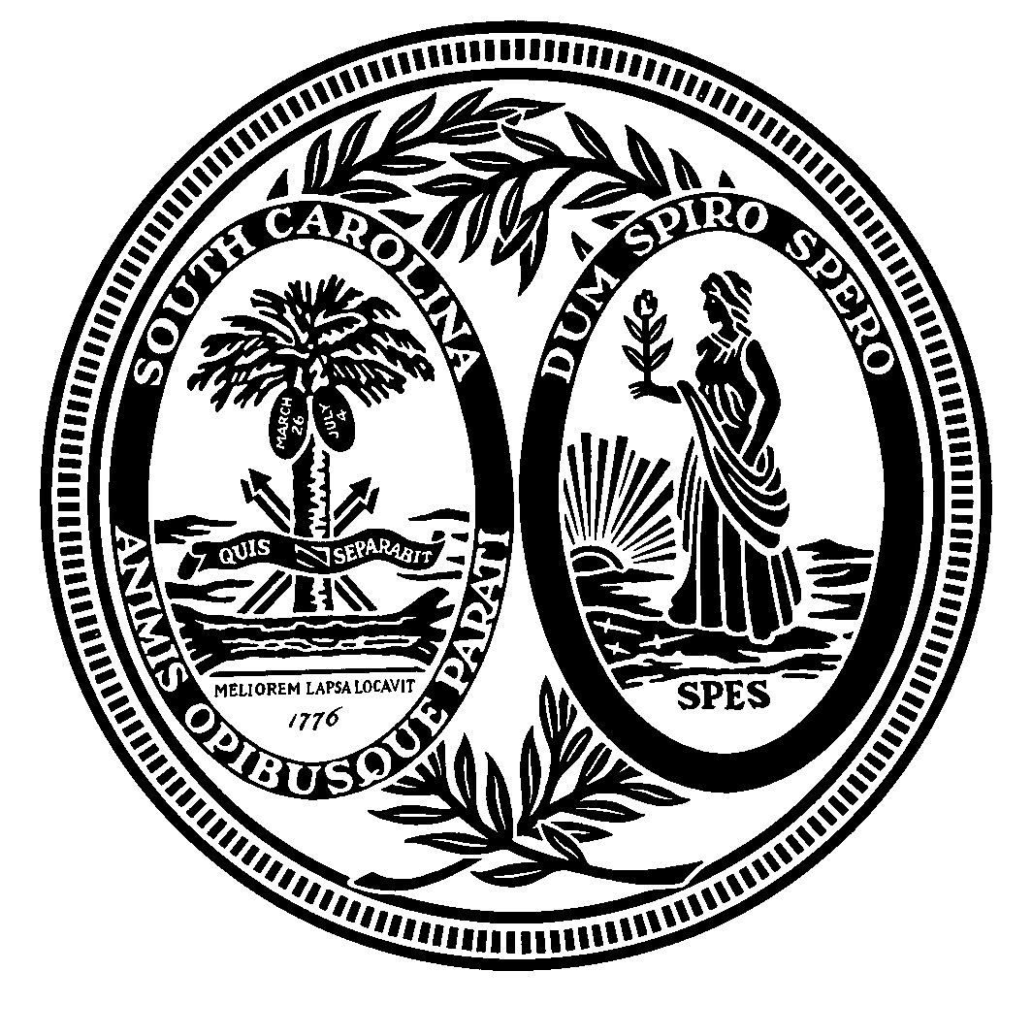
Senator Paul G. Campbell, Jr.
Senator Tom Davis
Representative Russell W. Fry
Senator Lawrence K. “Larry” Grooms
Senator Bradley Hutto
Representative Peter M. McCoy, Jr.
Governor Henry McMaster
Representative Russell L. Ott
Representative G. Murrell Smith, Jr.
Post Office Box 142
Columbia, South Carolina 29202

Agenda

Wednesday, August 22, 2018
9:30 a.m.
Room 110, Blatt Building

I. Call to Order

II. Public Service Authority Presentation

III. Committee Discussion / Other Business

IV. Adjournment

